Day 3: Morning assessment

1. Print numbers from 1 to 10.

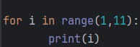 

2. Print even numbers from 1 to 20.

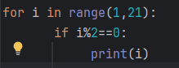 

3. Print odd numbers from 1 to 20.

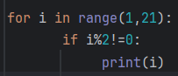 

4. Print numbers from 10 to 1 in reverse.



5. Print multiples of 5 up to 50.

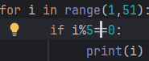 

6. Print the square of numbers from 1 to 5.

 

7. Print numbers from 1 to n (n taken from user).

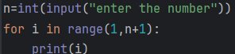 

8. Print all numbers between 1 and 100 divisible by 7.

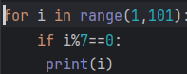

Output: 7 14 21 28 35 42 49 56 63 70 77 84 91 98

9. Print numbers from 1 to 50. If number is even, print "Even", else print "Odd".

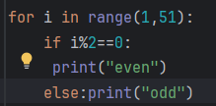 

10. Print first 10 natural numbers. For each number, print its square.



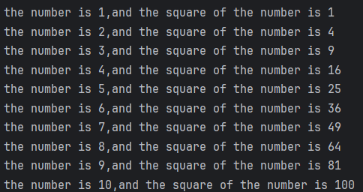

11. Print each element of a given list.

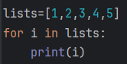 

12. Find and print only positive numbers from a list.

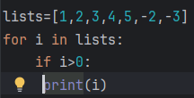 

13. Print numbers greater than 50 from a list.

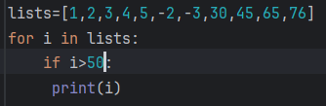 

14. Print all strings starting with letter ‘A’ from a list.

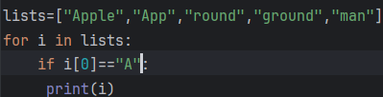 

15. Count how many even numbers are in a list.

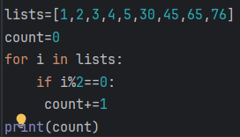 output:4

16. Print all numbers in a list which are divisible by 3.

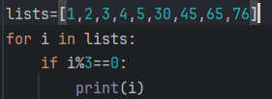 

17. Find the maximum number in a given list using for loop.

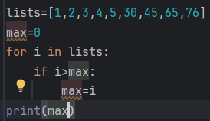 output:76

18. Find the minimum number in a list using for loop.

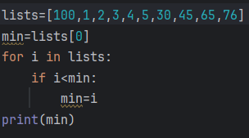output:1

19. Find the sum of all numbers in a list using for loop.

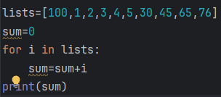output: 331

20. Find the average of all numbers in a list.

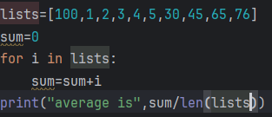output: average is 33.1

21. Print all prime numbers between 1 and 50.

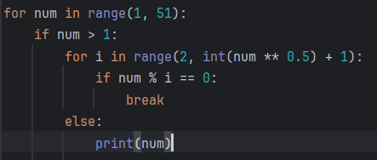

22. Print all numbers between 1 and 100. If divisible by both 2 and 5, print the number.

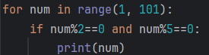

23. Print numbers between 1 and 30. If number is divisible by 3 print "Fizz", else print the number.

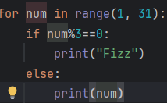

24. Print "Hello" 5 times using for loop.



25. Find and print the factorial of a given number using for loop.

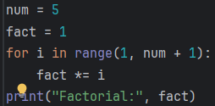out put: Factorial: 120

26. Count all vowels in a given string using for loop.

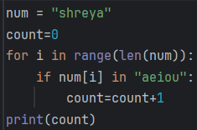

27. Reverse a given string using for loop.

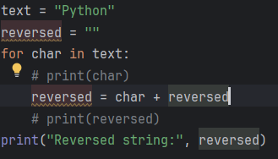

28. Find the sum of digits of a number using for loop.

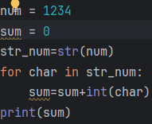output:10

29. Print a multiplication table of a given number using for loop.

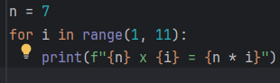

30. Check if a number is palindrome using for loop.

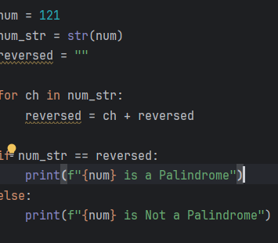

31. Take a number from user. Check if it is positive, negative, or zero.

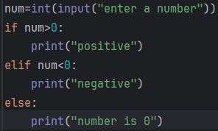

32. Take a year from user. Check if it is a leap year.

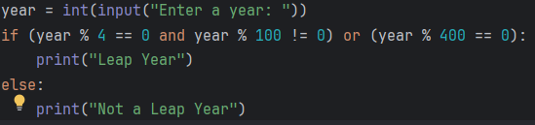

33. Take a number from user. Check if it is even or odd.

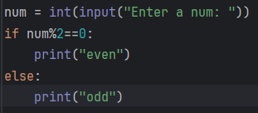

34. Take a number from user. Check if it is divisible by 5 and 11.

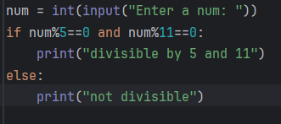

35. Take a character from user. Check if it is a vowel or consonant.

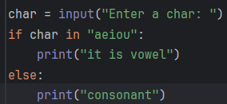 

36. Take a number from user. Check if it is a three-digit number.

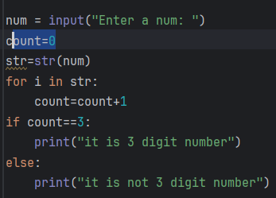 

37. Take a character from user. Check if it is uppercase or lowercase.

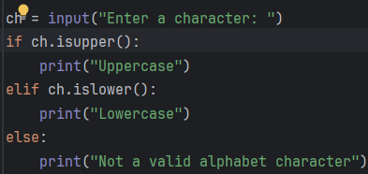 

38. Take age from user. Check if person is eligible to vote (age ≥ 18).

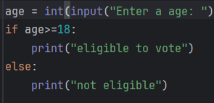 

39. Take a number from user. Check if it is divisible by 2, 3, or both.

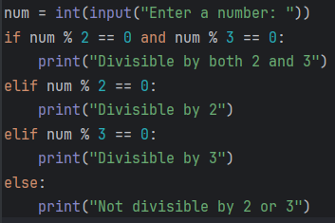 

40. Take a number from user. Print whether it is even, odd, or zero.

